**Monopoly**

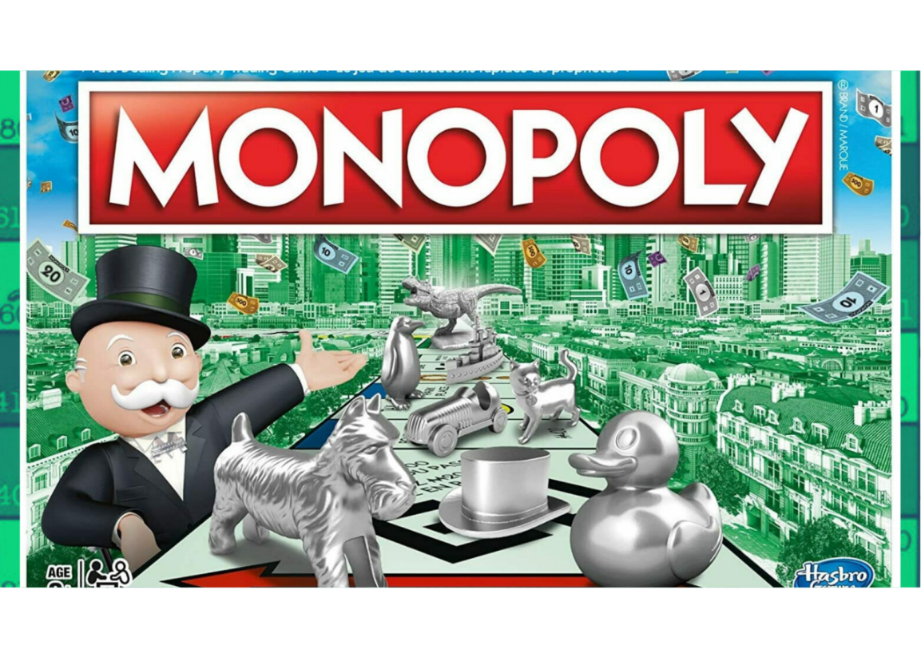

**Description:** A classic board game that combines strategy, luck, and economic management.

**How to Play:** Players buy, trade, and develop properties to become the wealthiest player while avoiding bankruptcy.

**Location:** Indoor

**Things Needed:** Monopoly board, cards, tokens, money

**Number of Players:** 2 to 8